WinUI 3 demo

Introduction
WinUI 3 is Microsoft’s new native UI framework available for packaged and non-packaged GUI applications (in Windows terms, that is, nothing to do with Delphi packages). WinUI 3 is part of the Windows App SDK (previously known as Project Reunion), where the Windows App SDK is separate to the Windows SDK (despite the very similar names). WinUI 3 is the current UI framework in the WinRT (Windows Runtime) architecture.
The sample project SampleWinRT is intended to show how to construct a simple Delphi GUI application purely out of Microsoft’s WinUI 3 (1.0) framework. Pre-release versions of WinUI3 required the application to be deployed as a Windows packaged application, but WinUI 3 (1.0) removes that restriction meaning that you can build a WinUI 3 app in Delphi as a regular app.
You can find more about WinUI 3 here: https://docs.microsoft.com/en-us/windows/apps/winui/winui3.
You can find more about the Windows App SDK here: https://docs.microsoft.com/en-us/windows/apps/windows-app-sdk/.
Note that the demo comes with updated versions of the WinRT Delphi RTL import units, to support the 1.0 release of WinUI 3.

Prerequisites
In order to build and deploy an unpackaged app you need a couple of things, as detailed on https://docs.microsoft.com/en-us/windows/apps/windows-app-sdk/deploy-unpackaged-apps
Firstly you need the Windows App SDK installer, which you can get from a download link on the aforementioned Microsoft page, or pull it down from https://aka.ms/windowsappsdk/1.0-stable/msix-installer. This gives you the redistributable file archive, currently called Microsoft.WindowsAppRuntime.Redist.1.0.0.zip, which contains installers for x86 and x64 platforms (both called WindowsAppRuntimeInstaller.exe) in sensibly named folders.
Running the installer (with elevated privileges) will ensure that you have the Windows App Runtime installed – it goes into hidden folders under C:\Program Files\WindowsApps, for example the x86 version might be installed within C:\Program Files\WindowsApps\Microsoft.WindowsAppRuntime.1.0_0.319.455.0_x86__8wekyb3d8bbwe.
The second thing you need is the Windows App Runtime loader DLL, Microsoft.WindowsAppRuntime.Bootstrap.dll. This file is obtained from within the Windows App SDK NuGet package, currently Microsoft.WindowsAppSDK.1.0.0.nupkg, which is available from https://www.nuget.org/packages/Microsoft.WindowsAppSDK in the folder runtimes\win10-x86\native or runtimes\win10-x64\native. This DLL should be placed alongside your executable in order to be located at application startup when the relevant APIs are called. The loader DLL (or bootstrap DLL) is responsible for locating a suitable version of the Windows App Runtime, which implements WinUI 3, based on the version values passed into its startup API.

Introduction to the demo
The demo application is built as a console app, not out of necessity, but so information can be written to the console window as the application progresses.
Note: WinUI 3 requires you to run the process without elevated privileges. As such, the demo checks this and exits with a simple message if it finds elevated privileges. Without this check in place, WinUI 3 crashes the application in a seemingly graceless manner.
Assuming we pass the privileges check the app calls the initialization API in the loader DLL, MddBootstrapInitialize, and if that locates and starts up the Windows App Runtime the application then proceeds with further initialization. Before exiting the app calls MddBootstrapShutdown to clean up.
uses
WinRT;
const
// From include\WindowsAppSDK-VersionInfo.h in WinAppSDK NuGet package
WINDOWSAPPSDK_RELEASE_MAJORMINOR = $00010000;
WINDOWSAPPSDK_RUNTIME_VERSION_UINT64 = $0000013F01C70000;
WINDOWSAPPSDK_RUNTIME_VERSION_DOTQUADSTRING = '0.319.455.0';
var
PackageVersion: PACKAGE_VERSION;
...
PackageVersion.Version := WINDOWSAPPSDK_RUNTIME_VERSION_UINT64;
var HR := MddBootstrapInitialize(WINDOWSAPPSDK_RELEASE_MAJORMINOR, nil, PackageVersion);
if Succeeded(HR) then
try
Main;
WriteLn('Press Enter (again) to continue');
Readln;
finally
MddBootstrapShutdown;
end;

As you can see, the SDK release and runtime package versions are borrowed from a header (.h) file located within the Windows App SDK NuGet package
Within Main we call the static Start method of the WinUI 3 Application object – see https://docs.microsoft.com/en-us/windows/winui/api/microsoft.ui.xaml.application.start. This takes a callback that will be run when the application initializes, allowing us to set things up as we wish. Fortuitously, WinRT callbacks (including WinUI 3 callbacks) have the same implementation as a Delphi anonymous method so we use an anonymous method to set up our application’s OnLaunched event handler.
In WinUI 3 OnLaunched is not actually an event handler. Instead OnLaunched - https://docs.microsoft.com/en-us/windows/winui/api/microsoft.ui.xaml.application.onlaunched - is a method that we are expected to override in a class that inherits from the WinUI Application class. How do we cope with this requirement to inherit from a WinRT class from Delphi?
WinUI helps us out by supplying a mechanism that we can make use of. In a case like this, inheriting from a WinUI 3 class involves 3 objects:
- An inner object that gives the base implementation, which is provided by WinUI, in this case a base Application implementation. This inner object will implement an interface that defines the method(s) we will be providing implementations for; IApplicationOverrides in this case.
- An outer object (sometimes referred to as a base object) that provides the custom implementation of the method(s) in question. This outer object, which we will provide, will also implement IApplicationOverrides.
- A wrapper object, which combines the inner and outer object, and is provided by WinUI
Here is the code from Main:
var AppInner: IInspectable;
var AppOuter: IApplicationOverrides;
var AppWrapper: IApplication;

// In this code block we use an anonymous procedure (which Delphi implements as an
// interface with an Invoke method) that matches the layout of the callback interface
type
TCallbackProc =
reference to procedure (p: IApplicationInitializationCallbackParams) safecall;

procedure Main;
begin
// Here we define an anonymous method and cast it to the matching WinUI interface type
var CallbackProc: TCallbackProc :=
procedure (p: IApplicationInitializationCallbackParams) safecall
begin
// First we create our derived class
AppOuter := TDerivedApp.Create as IApplicationOverrides;
// Then we get the IApplicationFactory...
var Factory := TApplication.Factory;
// ... and use it to get an IApplication wrapper, AppWrapper,
// and an IApplicationOverrides inner as well
AppWrapper := Factory.CreateInstance(AppOuter, AppInner);
// We store the inner object in the outer one so
// we can call the base functionality when needed
AppOuter.Inner := AppInner as IApplicationOverrides;
end;
var AppInitCallback := ApplicationInitializationCallback(CallbackProc);
TApplication.Start(AppInitCallback);
end;

The application customization code is from this class:
type
TDerivedApp = class(TInspectableObject, IApplicationOverrides)
private
FInner: IApplicationOverrides;
public
{ IApplicationOverrides methods }
procedure OnLaunched(args: ILaunchActivatedEventArgs); safecall;
...
property Inner: IApplicationOverrides read FInner write FInner;
end;

The OnLaunched method is then at liberty to do all the app setup required. In this case we create and set up a Window - https://docs.microsoft.com/en-us/windows/winui/api/microsoft.ui.xaml.window and populate it with some controls.
Look in the code for all the details of what goes on, but in summary:
We create a StackPanel control and put it in the window, then a button is created with a Click event handler and added to the StackPanel.
Next we use some XAML to create another StackPanel and a button child control, again with a Click event handler, adding the StackPanel to the window. That gives us 2 approaches to achieve the same goal.
Finally some more XAML is used to create a Grid and within that a TextBlock, which then has a couple of event handlers added for OnPointerEntered and OnPointerExited.
Ultimately we end up with a window showing a couple of buttons and a text block. The buttons can be clicked to change their caption and the text block changes color when you move the mouse into and out of it:
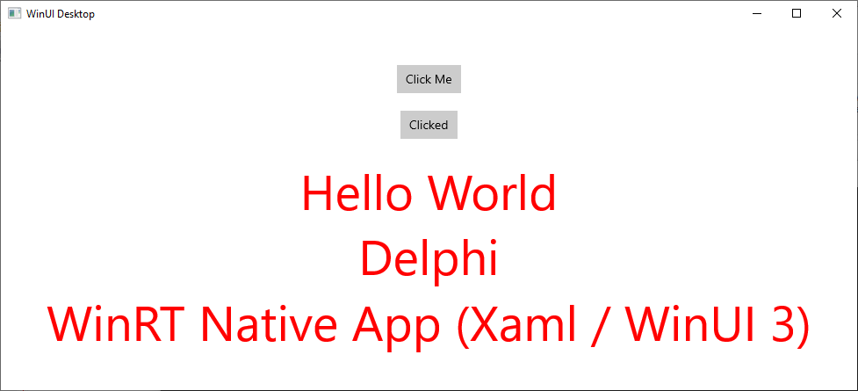
Note: unlike C# and C++ the language projection for Delphi does not currently incorporate all the various interfaces implemented by WinRT and WinUI 3 objects into unified proxy classes, and so there is a lot more interface work going on than would be the case elsewhere.

